Can Mechanistic Explanation be Reconciled with
Scale-Free Constitution and Dynamics?

William Bechtel
Department of Philosophy, Center for Circadian Biology,
and Interdisciplinary Program in Cognitive Science
University of California, San Diego

Abstract

This paper considers two objections to explanations that appeal to mechanisms to explain biological phenomena. Marom argues that the time-scale on which many phenomena occur is scale-free. There is also reason to suspect that the network of interacting entities is scale-free. The result is that mechanisms do not have well-delineated boundaries in nature. I argue that bounded mechanisms should be viewed as entities scientists posit in advancing scientific hypotheses. In positing such entities, scientists idealize. Such idealizations can be highly productive in developing and improving scientific explanations even if the hypothesized mechanisms never precisely correspond to bounded entities in nature. Mechanistic explanations can be reconciled with scale-free constitution and dynamics even if mechanisms as bounded entities don’t exist.

1. Introduction

Fundamental to the project of mechanistic explanation, both as pursued in biology over the past two centuries and as characterized by the proponents of the new mechanistic philosophy of science, is the identification of mechanisms responsible for phenomena for which explanation is sought. Mechanistic explanations then attempt to decompose these mechanisms into their parts and operations and show that when appropriately organized these components can generate the various phenomena. A natural interpretation of this approach to explanation is that mechanisms and their components exist as well-delineated entities in nature and operate on characteristic timescales. A good mechanistic explanation describes the responsible mechanism (Craver, 2007). Marom (2010) raises a serious and important objection to this account of mechanisms by showing that many biological (including psychological) phenomena do not exhibit a characteristic timescale. The time-course of the phenomenon is scale-free so that there is no well-delineated temporal window in which a hypothesized mechanism could generate this phenomenon. Operations in the distant past of the mechanism itself affect how it operates in the present.

While Marom’s objections focus on the temporal dimension, similar concerns can be raised about the constitution of a mechanism at a given time. While mechanisms are assumed to receive inputs from outside and send outputs to other entities, they are generally taken to be bounded entities that are responsible for a phenomenon. This is manifest in Craver’s (2007) diagrammatic representation of a canonical mechanism (Figure 1). The mechanism (bottom) responsible for a phenomenon (top) is represented as an oval with a sharp boundary surrounding its components and separating them from what then counts as the external environment. The mechanism is distinct but not isolated: one arrow penetrates the boundary to affect one component, and another arrow extends outwards from a different component. These arrows represent the fact that other entities in the environment (not explicitly shown) connect causally with certain parts of the mechanism of interest. These external entities may be ions at some concentration in a fluid, or may themselves be mechanisms, or whatever else may be causally salient. Inside the boundary, each part (X_{i}) performing one operation (Φ_{i}-ing) is itself enclosed in a smaller oval—Craver’s way of conveying that each of these constituent ovals can itself be regarded as a mechanism that could be unpacked into its own parts and operations. Each oval (the large one and the several small ones) delineates a mechanism distinct from others. Successful mechanistic explanations at each level, on this view, explain the behavior of mechanisms in terms of their constituents.

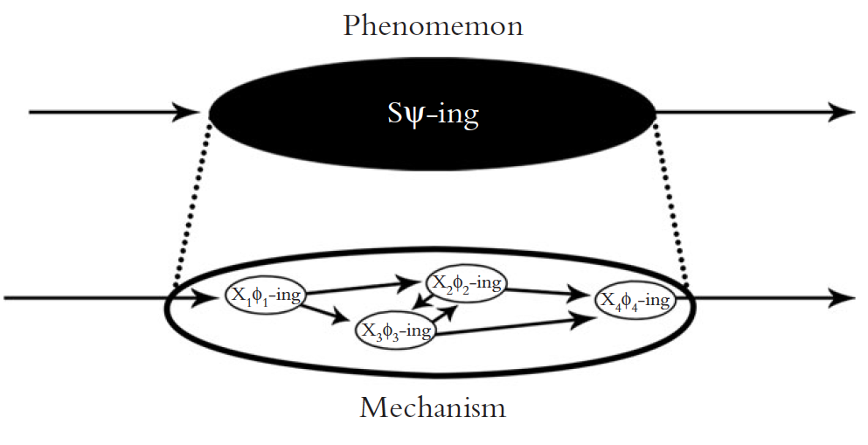
Figure 1. Craver’s (2007) representation of a mechanism responsible for a phenomenon (top) as a dark oval enclosing component mechanisms (bottom).

This picture, however, is highly misleading, as I will argue in section 3. The parts and operations taken to constitute a mechanism responsible for a given biological phenomenon are often found to have a multitude of causal interactions with entities and activities initially taken to be outside the mechanism. Whereas Figure 1 suggests very sparse causal relations crossing the boundary—involving what are often regarded merely as inputs and outputs—there are frequently so many interactions that the practice of designating discrete mechanisms is called into question. When represented in a graph theoretical manner, the parts and operations can be seen as entities within large networks that are also scale-free in the sense that there is not a well-defined scale on which to characterize the boundaries of the mechanism within the network.

Marom’s appeal to scale-free time-scales and the recognition that the parts of mechanisms are enmeshed in scale-free networks both reveal that mechanisms are not sharply delineated in nature. Explanations do not simply characterize mechanisms differentiated by well-defined boundaries. Rather, scientists propose mechanisms as they develop mechanistic explanations. That is, they hypothesize that entities are organized together as parts of a mechanism and through their coordinated operations produce the phenomenon. It is the scientists who impose boundaries around entities and activities in nature and impose a time scale on which their functioning is characterized. For different explanatory purposes researchers may draw these boundaries in different locations or at different time points. These choices, though, while not simply responsive to pre-existing boundaries, are not entirely arbitrary. As I discuss in section 4, the networks of entities found in nature commonly exhibit small-world organization as well as being scale-free. This entails that while real-world networks are highly interconnected, there are clusters within them that are semi-independent of the rest and productively posited to be the mechanisms responsible for specific phenomena.

While not arbitrary, mechanism posits are nonetheless idealizations in that they misrepresent the behavior of the mechanism as solely due to its components and their organization; they neglect the roles interactions with other entities play in determining the mechanism’s behavior. Godfrey-Smith (2009), among others, distinguishes idealization from abstraction: whereas abstraction involves merely leaving out information, idealization involves the introduction of simplifying falsehoods in a model. Assuming that activities in a mechanism are not affected by entities outside its boundaries (except for those distinguished as providing inputs) or activities outside its time-window involves abstraction, but these assumptions are false and simplifying. Hence, these assumptions are also idealizations (although typically not adopted with the awareness that they are false).

In arguing that the idealized accounts of mechanisms are nonetheless valuable as mechanistic explanations, I invoke the perspective Richardson and I (Bechtel & Richardson, 1993/2010) introduced: explanations that localize phenomena in parts of a system, when successful, are only accurate to a first approximation. Starting from such a localized explanation, further research often unveils the interconnections of those components with others. Researchers who seek to pursue these effects then expand the boundaries of the mechanism. The expanded account, however, is still not a complete account and it would be both unrealistic and unproductive to try to incorporate all relevant factors in an explanation. The mechanism hypothesized in a mechanistic explanation remains an idealization in that it fails to give a fully correct account of the phenomenon occurring in nature.

In section 5 I turn specifically to Marom’s argument that the time-scale on which biological phenomena are produced is scale-free. I construe this as providing further evidence that the mechanisms hypothesized in mechanistic explanations are idealizations. But there is an alternative perspective: such results can be viewed as pointing to the need to supplant mechanistic explanation with an alternative type of explanation that employs an appropriate mathematical framework to accommodate activity on scale-free time-scales. This seems to be the perspective favored by Braun and Marom (this issue). While granting the value of appropriate mathematical representations, I argue for the continued pursuit of mechanistic explanations that impose time-windows in which the activity of a mechanism is hypothesized to operate. Such research is extremely valuable in revealing components that account for the phenomenon of interest to a first approximation. Once an account that sufficiently approximates the phenomenon is developed, then expanding the time-window can allow for incorporation of more effects, leading to improved approximations when desired.

My overall contention is that recognizing the scale-freeness of networks and time-scales does not undercut the project of mechanistic explanation, but is helpful in revealing that the mechanisms proposed are posits of the scientists developing the explanation. They do not exist in nature as well delineated entities. The goal of mechanistic explanation is not to represent mechanisms as they exist independently of scientists. Rather, it is to show what phenomena the parts and operations selected by the scientists, operating in the time-window they consider, can largely account for. While this may limit the aspirations of both scientists pursuing mechanistic explanations and philosophers characterizing their project, it does not challenge the value of pursuing mechanistic explanation and in the process idealizing mechanisms by delineating boundaries that do not exist in nature.

2. Delineating Mechanisms in Mechanistic Research

Although the pursuit of mechanistic explanations has been widespread in biology for three centuries, it was largely neglected by 20th century philosophers of science who, inspired by some parts of classical physics, treated laws as fundamental to explanation. Phenomena, on this view, were explained when descriptions of them could be derived from laws and initial conditions (Hempel, 1965). The fact that explanations in biology seldom explicitly appeal to laws, though, has led some philosophers to focus on what biologists frequently do offer when they seek to explain phenomena—accounts of the responsible mechanisms. Although there are significant differences in their construal of what mechanisms are taken to be (one of which will become important in section 5), these accounts all emphasize that mechanisms are construed as systems consisting of parts performing operations that are organized appropriately to generate the phenomenon of interest (Bechtel & Richardson, 1993/2010; Bechtel & Abrahamsen, 2005; Bechtel, 2011; Machamer, Darden, & Craver, 2000; Craver, 2007; Darden, 2008; Craver & Darden, 2013; Glennan, 1996, 2002). Many of these accounts emphasize the process of discovery whereby scientists develop initial accounts of the mechanism they take to be responsible for a phenomenon and then refine them in the course of further inquiry.

Typically the search for a mechanism begins with a phenomenon that scientists have identified for which they seek explanation. As presented by Bogen and Woodward (1988), phenomena are repeatable features in the world; as examples they offer “weak electrical currents, the decay of the proton, and chunking and recency effects in human memory” (p. 306). An example that will provide the basis for the discussion in the next section is circadian rhythmicity: many organisms exhibit an approximately 24-hour endogenously generated rhythm in their physiological and behavioral activities. Although such abstractly characterized phenomena are often treated as the targets of explanation in science textbooks and philosophical accounts of mechanistic explanation, they are not the phenomena that scientists typically seek to explain. Rather, a phenomenon is characterized in much more specific detail, often quantitatively. Such quantified characterizations are generally the product of extensive research, often involving many experimental manipulations. For example, the generic description of circadian rhythms resulted from decades of research that examined the free-running behavior of organisms removed from time cues provided by their environment and then showing how that behavior could be advanced or delayed by pulses of light. A prototypical example of this type of circadian phenomenon is presented in the phase response curve shown on the left panel of Figure 2; it shows how much the circadian oscillation in locomotor activity of a hamster housed in constant darkness is advanced or delayed by pulses of light at various times of day (shown in Circadian Time, where 0 is the time an organism expects the light phase to begin). The figure shows that light pulses around the expected onset of darkness delays the phase of the circadian rhythm whereas a light pulse later in the night advances it. The quantitative pattern of responses depicted in this curve is then the target of explanatory efforts. The phenomenon discussed in section 5, the action potential, is also quantitatively characterized. Prior to Hodgkin and Huxley’s (1952) much discussed paper advancing a mathematical model of the action potential, these researchers and others engaged in over a decade of research using electrodes implanted in the squid axon to record the voltage changes during action potentials (Hodgkin & Huxley, 1939, 1945). The result of this research was to establish the quantitative pattern of depolarization, repolarization, and overshoot shown on the right in Figure 2.

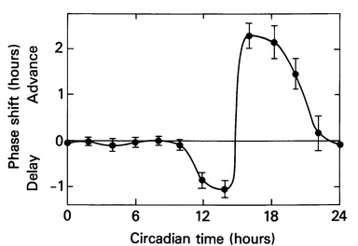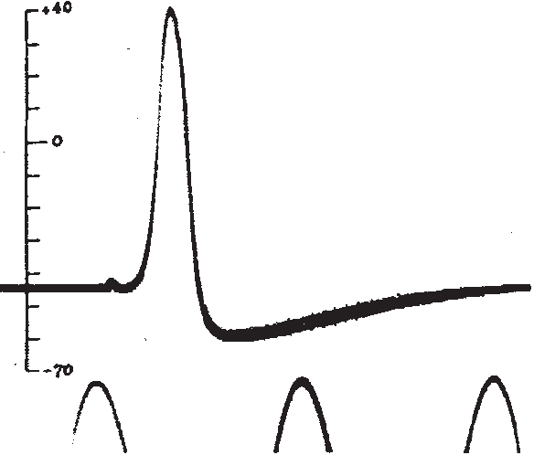
Figure 2. Left: phase response curve showing how much the circadian activity of a mouse is delayed or advanced by light pulses. From Takahashi, DeCoursey, Bauman, and Menaker (1984). Right: Hodgkin and Huxley’s (1939) recording of an action potential from the squid. A time marker of 500 cycles/second is shown along the bottom.

The search for a mechanism responsible for such a phenomenon sometimes begins by identifying where in a larger system the mechanism responsible for a given phenomenon is located and sometimes by identifying a part of the responsible mechanism. Both are exemplified in circadian research. First, Moore argued that the circadian clock in mammals is localized in a reasonably well-delineated organized system, the suprachiasmatic nucleus (SCN) in the hypothalamus. He did this by showing that lesions to the SCN resulted in elimination of rhythms (Moore & Eichler, 1972) and by identifying a neural pathway from the retina to the SCN that made entrainment by light possible (Moore, 1973). The SCN is treated as the locus of control for circadian rhythms and colloquially referred to as “the clock.” Second, by inducing mutations and monitoring their effects, Konopka and Benzer (1971) identified a gene in fruit flies, period (per) in which mutations could generate rhythms with short or long periods or arrhythmic behavior. They took the gene or the product for which it codes to figure in the mechanism.

Once a putative part has been identified, the next challenge is to figure out how it functions in the mechanism. When it became possible to measure the concentrations of per mRNA and of the protein PER, Hardin, Hall, and Rosbash (1990) discovered that concentrations of the mRNA and protein produced from the gene per rose and fell once every 24 hours. From this information they proposed a mechanism involving a transcription-translation feedback loop: after PER was synthesized in the cytoplasm of a cell, it was transported back into the nucleus where it inhibited further transcription of per. PER would gradually break down, and as it did so, transcription would resume. Hardin et al. proposed that the timing of PER synthesis, transport into the nucleus, and subsequent break down results in the 24-hour oscillations in concentrations of per mRNA and PER. A great many details remained to be filled in through research over the succeeding fifteen years. During that time researchers determined that the mammalian clock works in basically the same way, employing orthologs of many of the genes found in fruit flies. The left panel in figure 3 shows the basic conception of the intracellular mechanism that had been arrived at by 2005. It is somewhat abstract, in that it collapses some parts and operations and omits numerous already known additional components, such as kinases that figure in the degradation of the various proteins.

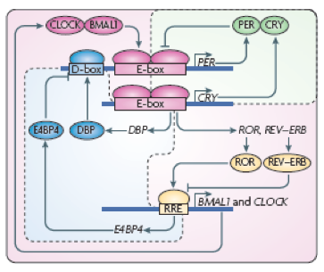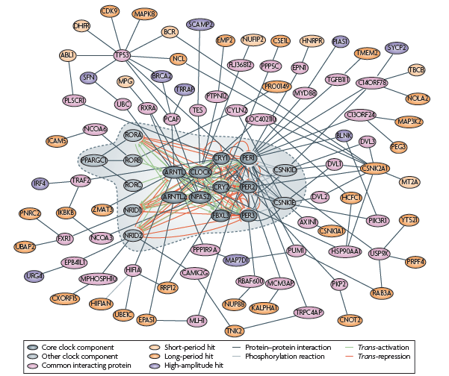
Figure 3. Two parts of a figure from Zhang and Kay (2010). The panel on the left shows the major components of the mammalian circadian clock as understood in 2005. In the right panel these components are shown within the dotted line in the center. The surrounding regions show proteins that were determined through siRNA screens to affect the period or amplitude of the core circadian rhythm. Edges connect them to the components of the core clock mechanism they affect.

3. Mechanism Boundaries Are Not Well-Defined

The understanding of the clock mechanism diagrammed in Figure 3 seems to comport very well with Craver’s representation of a prototypical mechanism in Figure 1. Different shapes with types of labels are used to distinguish types of parts: labels in italics above long blue bars identify genes; labels inside rectangles on those bars pick out promoter regions of genes; labels inside ovals stand for proteins; and unlabeled ovals differentiate those proteins when bound to the promoter region. Long arrows indicate the operations of those parts: a pointed arrow from gene to protein indicates transcription and translation and a pointed arrow (or flat-headed arrow) from protein to gene promoter box indicates a protein feeding back to activate (or inhibit) its gene. The diagram’s designers drew a box around all of this, in accord with the idea at the time that the clock was a discrete mechanism. Although there are no arrows crossing this boundary, other diagrams of the era often added an arrow from an external sun icon to indicate entrainment to the periods of light and dark in the local environment and extended another arrow out from the mechanism to indicate the role of the clock in regulating physiology and behavior by controlling the expression of other genes.

The reason Zhang and Kay (2010) published this diagram representing the state of knowledge in 2005 was to draw a contrast with the diagram shown in the right panel of Figure 3. Over the intervening years new techniques such as genome-wide screens with small interfering RNAs (siRNAs) had identified more than 200 hundred additional proteins that have effects on the period and amplitude of the oscillations of the core clock components. Period and amplitude of oscillations are the defining features of a circadian clock, not incidental features. In this figure, the proteins taken to constitute the core clock mechanism, with the operations that causally link them, are shown in the gray patch in the center, surrounded by a dotted line. The proteins newly found to have effects on core components are shown in the surrounding area (any line from one of these to a component of the core clock indicates such an effect). These other proteins are normally treated as parts of signaling pathways in other cellular mechanisms, especially those involved in regulating insulin metabolism, the cell cycle, Hedgehog signaling, and folic acid biosynthesis, but this research reveals they also have important functions in generating circadian rhythms. The components of the core clock mechanism are integrated into a network of other entities, with the result that the core clock mechanism does not seem to be sharply delineated from the rest of the network.

A specific example will help illustrate the challenges that have recently been raised to the assumption that the clock mechanism is sharply distinguished from other cellular mechanisms. The mechanisms involved in basic metabolism (glycolysis and oxidative phosphorylation) were long regarded as distinct from the circadian clock mechanism. There was reason to expect that they were regulated by the clock, but not directly involved in the functioning of the clock mechanism. Recent research, however, has revealed that NAD⁺, a major product of metabolic processes such as glycolysis and oxidative phosphorylation, plays an important role in a critical operation in the circadian clock in which the protein CLOCK activates the transcription of Per and Cry. As NAD⁺ is generated, it inhibits further transcription of Per and Cry. After reviewing this and several other connections between metabolic mechanisms and circadian mechanisms, Bellet and Sassone-Corsi (2010, p. 3845) conclude that “accumulating evidence shows there is a mutual relationship – the clock controls some crucial metabolic pathways and metabolism feeds back to the clock machinery.”

The close interaction between parts of the putative clock mechanism and parts of other mechanisms is exhibited not only at the molecular level, but also at the level of the SCN. Researchers have found a variety of effects of signals from other parts of the brain and body on different populations of SCN neurons. One example out of many is that melatonin synthesis in the pineal gland is regulated by the SCN, but many SCN cells have receptors through which melatonin in turn regulates their behavior. Graphical presentations of either intracellular or SCN clock activity look less like Figure 1 and more like the interconnected network on the right in Figure 3.

4. Positing Mechanisms in a World of Scale-free Small-World Networks

The research described in the previous section reveals that the circadian clock mechanism is not sharply differentiated from other biological mechanisms—the putative components of the clock interact not just among themselves but with many other entities, including parts of other mechanisms. It is the cognitive activities of investigators that picked out some entities as the parts constituting the clock mechanism and screened off or ignored the effects of other entities on these parts. Thus, it was the researchers who chose where to draw boundaries around the clock mechanism in diagrams such as in Figures 3. In particular, the scientists have deemed specific entities as particularly relevant to explaining the phenomenon they were interested in and have included them in the mechanism. This involves creating boundaries in an interconnected world.

The drawing of such boundaries, however, is not completely arbitrary. While there are not sharp boundaries between mechanisms, many biological systems exhibit the properties of scale-free small-world networks that support drawing boundaries for explanatory purposes at particular locations. The characterization of scale-free small-world networks represents an important development in graph theory. Although diagrams such as those in Figures 1 and 3 contain more detail than is typically included in graph representations (for example, they distinguish the type of operations various parts perform), they are in their essence causal graphs in which nodes represent entities and edges represent activities through which one entity affects another. Although the number of possible graphs is unlimited, graph theorists have developed a variety of measures that provide useful ways of classifying graphs and differentiating how systems realizing graphs of a particular type will behave. Three are of particular relevance to understanding where it is productive to draw boundaries of mechanisms: (1) the clustering coefficient that characterizes the average percentage of realized edges out of all possible edges from a node to others in its neighborhood; (2) the mean characteristic path length that refers to the mean number of edges that minimally must be traversed to get from one node to another; and (3) distribution of node degree that characterizes how the number of edges connected to a given node is distributed. Figure 4 illustrates the concepts of path length (four edges are required to get from A to B along the shortest path) and clustering (five of the six possible edges from B to its neighbors are realized). The node degree ranges from 2 to 5.

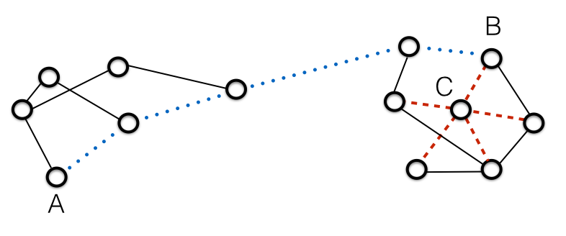
Figure 4. A network in which the dotted edges illustrate a path of length 4 between nodes A and B and a highly clustered set of nodes is illustrated by the dashed edges around node C.

Two types of graphs that were much studied in the 20th century have extreme values on the first two measures. Regular lattices such as shown on the left in Figure 5 have a high clustering coefficient since each node is connected to all others in its neighborhood, as well as a long characteristic path length since from a given node several edges typically must be traversed to reach a specified target node. Random networks, on the other hand, have both a much lower clustering coefficient and a much shorter characteristic path length. Watts and Strogratz (1998) showed that if one successively rewires a regular lattice by replacing one edge with a random alternative, one encounters a range in which the characteristic path length becomes much shorter while clustering remains high. They introduced the label small-world for graphs in this region. They further showed that many real-world networks are small worlds and argued that such an organization is highly efficient for information processing since the nodes that are clustered constitute modules that can specialize in particular tasks even as their behavior is modulated by nodes relatively distant in the network.

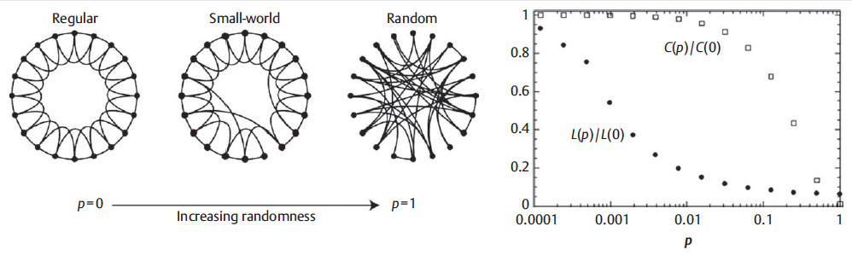
Figure 5. Left: As the probability of rewiring edges in a regular lattice increases one encounters first small worlds and then random networks. The right panel shows that the characteristic path length (L) drops with a low probability of rewiring, but that the clustering coefficient remains high until a much higher percentage is rewired. This intermediate range characterizes small-worlds. From Watts and Strogratz (1998).

The research on graphs considered so far assumed that the distribution of node degree is approximately normal. If degree is distributed normally, then there is a characteristic scale at which one can assess network structure. Investigations by Barabási and his collaborators (Barabási & Albert, 1999; Barabási & Bonabeau, 2003) revealed that in many real-world networks degree is not distributed normally, but according to a power law. In such networks, some nodes have a degree that is orders of magnitude larger than others so that there is no characteristic scale for characterizing the distribution of degree. These networks are termed scale free. There is no point on a scale at which one can mark a cut-off and capture all the relevant connectivity. This is especially problematic since the nodes with exceptionally high degree are typically very important to the functioning of the network due to the fact that they have edges linking them to many other nodes and thus have widespread effects.

When a small-world network (thus, having clusters that are referred to as modules) is also scale-free, the nodes with particularly high degree often serve as hubs integrating the nodes within a module (provincial hubs) or between modules (connector hubs). Both of these kinds of hubs are exhibited in Figure 6, although given the size of the overall network, degree ranges over just one order of magnitude (1 to 11) so that this network is not technically scale-free. Even so, it illustrates the important point that while the whole network is highly interconnected so that it has a short mean path length, the overall network is far from random. Within it are modules with high clustering so that most of the components that affect a given node are from the same module.
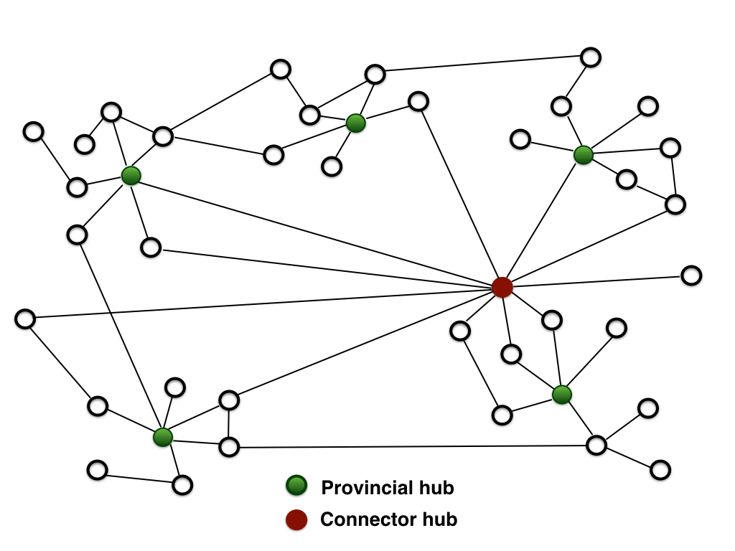
Figure 6. Network with five modules that exhibit high clustering. Although most nodes are connected to others by only one or two edges, some have many more. Given the finite size of this network, node degree varies only over a single order of magnitude, but in a much larger network the hubs would have several orders of magnitude more connections than the none hub nodes. Each module has a provincial hub and there is one connector hub.

The modules in a scale-free small-world network can be viewed as mechanisms if the nodes in them collaborate in the production of a phenomenon. Determining whether they do so and what phenomenon they produce requires going beyond the graph representation, which only shows through edges that a node affects another node but doesn’t specify the operations that it performs in doing so. Treating a module as a mechanism would require providing this information. To provide a full account of how the module behaves one would need to take into account both the connections between it and other nodes in the module and the connections between these nodes and nodes elsewhere in the larger network. The mechanistic account would focus only on the connections within the module except for connections that are treated as providing inputs and outputs. It will, thus, misrepresent how the module actually behaves since it does not take into account all the interactions with nodes outside the module. The hope of the mechanistic researcher, though, is that the proposed mechanism will provide an account that sufficiently approximates the behavior of the mechanism, one that can be regarded as accurate to a first approximation that can then be modified and refined by considering other connections to edges outside the module. One reason for thinking that this strategy will prove successful is that there are many more edges within the modules than between them. Although the mere quantity of edges is not a fully reliable measure of the magnitude of the effects, this suggests that much of the behavior within the module will be determined by the components of the module. If that is the case, the misrepresentation will be limited and researchers will be able to account for the system to a first approximation by treating the modules as distinct mechanisms.

As a matter of practice, researchers must proceed by developing accounts that offer first approximations to the phenomenon. The alternative is to embrace a holism that makes it impossible to identify distinctive contributions of parts of the system. Often researchers develop such approximations by averaging over the inputs from elsewhere in the network or by creating experimental situations in which these external inputs are kept constant (what Cartwright, 1999, calls nomological machines). Once the first approximation is available researchers can begin to take into account additional inputs when it is relevant to do so. Typically this will only be done in situations where it is important to understand the effects of specific other factors on the operation of the mechanism. The current interest in the relations between circadian rhythms and conditions such as obesity provide a motivation for determining how circadian and metabolic processes that were taken to be separate are integrated. The result will not be an account capturing all the interactions, but one that includes those interactions thought to be most relevant to the particular phenomenon of interest.

Scale-free small-world networks have been identified in many domains of biology, including in gene and protein regulatory networks (Albert, 2005). This provides support for the proposal that in much of biology one can make sense both of the fact that it is researchers that draw boundaries that delineate mechanisms and that this choice is not completely arbitrary. Researchers will draw their boundaries around a mechanism in such a manner that they include the major parts and operations that figure in generating a phenomenon of interest. These will typically correspond to modules in which nodes are highly interconnected. But these boundaries will exclude some of the components that do affect the behavior of the mechanism. When researchers identify components that are parts of other modules that nonetheless modulate the mechanism of interest, they can investigate how mechanisms are more integrated than they initially assumed. To focus on the interactions between the mechanisms they can combine two or more modules in a larger-scale mechanism.

5. Mechanism Time-scales are Scale-free
I turn now to the assumption about mechanism behavior that Marom has challenged—that there is a characteristic time-scale on which mechanisms operate. This assumption is in fact enshrined in Machamer, Darden, and Craver’s account of mechanisms as “productive of regular changes from start or set-up to finish or termination conditions” (2000, p. 3). This fits Marom’s (2010, p. 17) account of what it would be to have a characteristic time-scale: “the time taken to complete a trajectory through any well defined sequence of observable values”. Marom goes on to emphasize the importance of such timescales in mechanistic research: “much of the experimental work done in biological sciences in general, and neuroscience in particular, is aimed at exposing presumably intrinsic and uniquely defined timescales; they serve as guides in the search for microscopic mechanisms, and as a basis for most of the models in the field” (p. 17).

Marom argues, however, that for many biological processes there is no characteristic timescale. As an intuitive example, he appeals to Ebbinghaus’ (1885) classical research on remembering and forgetting in which Ebbinghaus tested his own memory for lists of nonsense words. As a measure of how much he had retained over an interval Ebbinghaus measured how many fewer trials it took to relearn a list than it took to learn it the first time. Conversely, the more trials it took to relearn the list, the more he had forgotten. Ebbinghaus’ important observation was that the rate of forgetting declined in proportion to the time interval, so that most forgetting occurred shortly after learning, yet continued at a slower rate until the end of the month interval in which he conducted his study. On the basis of their more recent studies, Wixted and Ebbesen (1997) have a argued that the pattern of forgetting is best fit by a power-law function, indicating that the process does not occur on a characteristic time-scale but over many orders of magnitude. Marom presents a list of other psychological phenomena that conform to a power-law function in which the timescale extends over several orders of magnitude: skill acquisition, somatosensory stimulus detection, sensorimotor coordination and time estimation, adaptation to sensory percepts, and recall of autobiographical memories. He concludes: “there seems to be a consensus amongst researchers that human performance obeys a timescale-free (mostly power) law” (p. 18).

Marom distinguishes two strategies for explaining power-law functions in higher-level performance: one could appeal to collectives of underlying processes that each have a characteristic scale or one could appeal to underlying processes that are themselves scale-free. Most researchers prefer the first strategy in which they search for a set of mechanisms each operating at its own time-scale. Marom argues that this assumption is likely to be flawed, but that the mistake is not likely to be detected since data is typically collected only over a limited timespan in which it is not apparent that it will be better fit by a power-law function. When longer timeframes are investigated, he argues that it appears that the underlying processes are themselves scale-free. As an illustration, Marom points to the research of Monto, Palva, Voipio, and Palva (2008). These researchers demonstrated scale-free dynamics in performance on a psychophysical task in which they stimulated the index fingers of their subjects at the threshold of detection and had them report whether they detected the stimulus with a thumb twitch. They found fluctuations in performance when looking at performance over long time scale, with more frequent and longer runs of hits and misses than would be expected by chance (i.e., when compared with random data). When researchers plotted the probability of runs against the length of runs lasting more than 15 seconds on a log-log scale, the relation was linear, indicative of scale-free dynamics. Simultaneously, they recorded full-band EEG, which allows detecting infraslow (0.01-0.1 Hz) fluctuations (ISFs). The relation of EEG power to frequency also exhibited a linear relationship on a log-log scale from 0.01 to 50 Hz, indicative that it also exhibits scale-free dynamics. Finally, the researchers showed that the phase of ISFs correlated highly with the subjects’ hits on the detection task.

Having argued for relating scale-free features of performance with scale-free aspects of the underlying neural system, Marom turns explicitly to the process of generating action potentials in individual neurons. Here he most clearly establishes the challenge to the idea that there is a characteristic scale on which one can identify the operation of the mechanism, showing that instead of well-defined termination conditions for an activity, there are detectable effects of earlier activity of the mechanism on its subsequent function for periods long beyond the supposed termination time. On standard accounts, the start condition is met when a neuron at its resting electrical potential receives an above-threshold excitation from other neurons and the termination condition is met when it returns to its resting potential, ready to respond to a new stimulus. Following Hodgkin and Huxley’s (1952) mathematical representation, this event is regarded as reaching completion in approximately 10 msec. This timescale, however, is an artifact of the fact that researchers typically look for effects only with this range. Hodgkin and Huxley themselves stated that they only recorded and modeled the short-term responses of the neuronal membrane; they thereby screened off any longer-term effects. Yet, already in their paper presenting the first recordings of action potentials in single neurons, Adrian and Zotterman (1926) showed that the probability of eliciting another action potential in a neuron depended on whether it generated an action potential several seconds earlier. They referred to this as adaptation.

After Hodgkin and Huxley developed their mathematical model of the generation of action potentials, most accounts attributed this longer-term effect to interactions between neurons, not to adaptation within individual neurons. Gal, Eytan, Wallach, Sandler, Schiller, and Marom (2010), however, deployed a strategy to investigate more thoroughly longer-term effects of action potentials within individual neurons. They cultured cortical neurons from newborn rats on multi-electrode arrays and blocked synaptic activity pharmacologically. This insured that the generation of action potentials in response to electrical stimuli was due only to endogenous processes. They then stimulated neurons with sequences of identical short electrical pulses (400 μs) and recorded whether and with what latency the neuron generated its own action potential. When stimulation was presented at a rate of 1 Hz a neuron would generate an action potential for each stimulus (stable regime). As shown in the top panel of Figure 7, when the rate of stimulation was raised to 20 Hz the spike latency gradually increased (transient regime) until a critical latency value was reached. It then entered an intermittent regime in which it would sometimes fail to spike and the latency fluctuated.

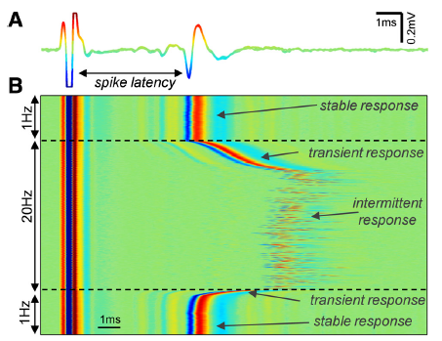
Figure 7. The top panel shows a neuron’s response first to stimuli delivered at 1 Hz and then at 20 Hz. At 20 Hz the latency increases until the response becomes intermittent. The bottom panel shows 55 hours (120 second on each line) of recording from a neuron stimulated at 20 Hz. A white dot indicates a response and extended bands of white and black reveal non-stable patterns throughout the recording. From Gal et al. (2010).

Gal et al. cited a vast literature indicating that most neurons in functioning brains reside in the intermittent regime in which they respond to only some of their incoming excitations, making understanding how neurons behave in this regime important. Moreover, arguing that the probability of responding and the latency of response can be viewed as measures of the excitability of the neuron itself, they set out to determine whether such earlier activity in the neuron affected current excitability. They examined the responsiveness of individual neurons over intervals as long as 55 hours (see bottom panel of Figure 8). If there were no correlations reflecting influences of much earlier activity on the neuron at a given time, then as larger bin sizes were used to bin the responses, the standard deviation should decrease. However, it remained the same whether they used 10 sec. or 1000 sec. bins. Their principal interest was in the nature of the variability in the periods when neurons are not excitable. Using several different measures, including a periodogram of nine neurons, they found results that in the low-frequency tail were best fit by a power-law function. This indicated that while most sequences were short, a few were extremely long; the periods when neurons are not excitable vary in duration over several orders of magnitude. Gal et al. conclude “The statistics of this response point to underlying processes that are practically timescale invariant, i.e., not characterized by a discrete and finite set of time constants; rather, there seems to be a continuum that covers any observable scale. . . . Altogether, these analyses reveal the long-range interdependencies and slow modulations that characterize neuronal activity when observed over extended durations.” (p. 16340).

Since Gal et al. ruled out exogenous factors as explaining the scale-free character of periods when neurons are not excitable, they concluded it must be due to endogenous factors such as the processes involving ion channels. A decade earlier Toib, Lyakhov, and Marom (1998) had found a power law relationship extending from milliseconds to minutes in the recovery process of specific sodium channels. Multiple sodium, potassium, calcium, and other channels interact in the production of action potentials and their behavior is coupled via membrane voltage and ionic concentrations among other factors. Gal and Marom (2013) developed a holistic model of such neuronal behavior that treats the neuron as a system exhibiting self-organized criticality that enables it to reside near a phase transition between excitable and unexcitable. Their intuitive portrayal is that without activity the neuron enters the excitable domain but that sufficiently high activity rates push the neuron into the unexcitable range, where it resides until regulatory feedback restores it to the excitable state. They develop a mathematical model to account for the scale-free behavior of neurons that depends on a global parameter for inter-channel interactions.

An alternative approach more in the spirit of mechanistic explanation would focus more on the knowledge of the behavior of specific channels over specific time intervals and build from them an account incorporating their interaction and longer time-scale effects. Initially the understanding of the specific channels would not include their interactions and the account of the whole would neglect the nonlinear interactions of components. As such it would serve only as a first approximation. Marom is explicitly skeptical of such an approach: “when such a ‘first’ approximation gives rise to theories about unique mechanisms, it may lead us to a dangerous scientific path” (p. 19). The history of research on action potentials that has ignored these long-term effects by limiting the focus to short timeframes provides evidence for the claim that researchers too often settle for the first approximation. But research such as Marom’s itself provides the needed corrective, revealing effects that are ignored by imposing one time-scale. Depending on their interests, researchers can choose different timescales in delineating a mechanism and by extending the timescale considered reveal effects that had previously been hidden. As a result, they can incorporate different operations into the mechanism, providing a better approximation to the phenomenon.

The subsequent accounts will remain approximations since the goal is not to incorporate every causal relation. Marom cites Borges’ comments on the cartographers who, in pursuing the goal of reflecting every detail in their maps, ended up with maps of the same scale as the land they represented (Borges, 1972). What is desired in both cartography and scientific explanation are accounts that identify the major processes operative in the production of the phenomenon of interest. This is where explanations must both abstract and idealize. Especially when false assumptions are made in developing explanations, it is important that they be made explicit so that the ways in which the resulting accounts misrepresent can be appreciated. If, in imposing a temporal scale, and in imposing a boundary around the parts and operations of a mechanism, researchers are aware of what they are potentially ignoring, then, when it becomes important, they can extend the scale or boundaries and consider additional aspects of a mechanism.

Conclusion

The simple account of mechanisms as well-delineated organized systems that operate on a characteristic time-scale does not correspond to the actual world, which is scale-free with respect to both causal connections and time-scales. If one takes the goal of mechanistic explanation to be to describe mechanisms as they operate in nature, then the scale-free character of nature points to the failure of mechanistic explanations. However, there is a very different reading of these results that does not require abandoning the project of advancing mechanistic explanation, although it does pose a cautionary note to any claim to have arrived at the mechanistic explanation for a given phenomenon. On this alternative view, mechanisms are viewed not as entities in the world, but as posits in mechanistic explanations that provide idealized accounts of what is in the world. Scientists impose boundaries, both by demarcating the entities treated as a mechanism and by specifying the time-scale on which the mechanism will be studied. Since there are no such boundaries that segregate activities in the world, the resulting mechanistic accounts are literally false.

Imposing boundaries, thereby generating idealizations, nonetheless serves an important role in the project of developing mechanistic explanations. Explanation, as an activity of humans, is constrained by aspects of our cognitive system, which reasons using representations of entities and their constituent parts performing activities or operations over tractable time-scales. Marom quotes Bridgman (1927), who gave voice to this when he spoke of “the apparent demand of our thinking apparatus to be furnished with discrete and identifiable things to think about” and noted that this imposed “a very essential restriction on any picture of the universe which we are able to form” (p. 93). Simon (1969) took this perspective a step further, arguing that only insofar as nature consists of what he called nearly decomposable systems can we understand them. He characterized a nearly decomposable system as one in which “(a) . . . the short-run behavior of each of the component subsystems is approximately independent of the short-run behavior of the other components; (b) in the long run, the behavior of any one of the components depends in only an aggregate way on the behavior of the other components” (p. 100). He presented as an example heat exchange in a building in which the walls between rooms are good insulators but those between cubicles are poor insulators. In describing the heat transfer between cubicles within a room we can ignore what is happening in other rooms, but when we turn to the transfer between rooms we can ignore the cubicle structure within rooms and consider the rooms as aggregates. Simon further characterizes the constitution relation in which local subsystems are hierarchically composed into larger systems and argues that decomposable, hierarchic systems are the only type that we are likely to be able to understand:
The fact then that many complex systems have a nearly decomposable, hierarchic structure is a major facilitating factor enabling us to understand, describe, and even "see" such systems and their parts. Or perhaps the proposition should be put the other way round. If there are important systems in the world that are complex without being hierarchic, they may to a considerable extent escape our observation and understanding. Analysis of their behavior would involve such detailed knowledge and calculation of the interactions of their elementary parts that it would be beyond our capacities of memory or computation (p. 108).
Simon does not totally rule out our observing and understanding systems that are not nearly decomposable, saying only that such systems may escape our detection and understanding to a considerable extent. He may thereby be allowing that we can develop complex mathematical models of such systems that provide a type of understanding.

In developing our account of mechanistic explanation, Richardson and I (Bechtel & Richardson, 1993/2010) drew explicitly on Simon’s account of nearly decomposable systems, but also maintained that decomposition and localization are heuristic principles—simplifying assumptions that facilitate inquiry but which may turn out to be false. We further argued that research based on these heuristics may reveal that the accounts are false because nature is less decomposable than initially assumed. Indeed, we described the discovery of what we referred to as integrated systems as resulting from the discovery of connections between components that were initially ignored. We also allowed that there are other types of explanation than mechanistic explanations. We offered neural networks as potentially outside the scope of mechanistic explanations (insofar as the nodes in such networks do not perform distinguishable operations). Instead, they describe mathematically the dynamics of a system of undifferentiated nodes. In subsequent years, dynamical systems accounts have been advanced in many fields, and their proponents have sometimes portrayed such explanations as alternatives to mechanistic ones (Chemero, 2009; van Gelder, 1998; van Regenmortel, 2004). Dynamical analysis, though, is often invoked in the service of mechanistic explanation when the system is sufficiently non-sequential and the operations non-linear. In such circumstances, researchers may need to invoke computational models to determine how the mechanism in question will behave. With Abrahamsen (Bechtel & Abrahamsen, 2010, 2012) I refer to such explanations as dynamic mechanistic explanations and with Levy (Levy & Bechtel, 2013) I have explored how computational modeling of the organization of mechanisms, abstractly characterized, can provide understanding of how mechanisms realizing particular modes of organization will behave. Thus, not all dynamical models are non-mechanistic—some are grounded on information about the parts and operations of a mechanism.

Without entering into the debate as to whether dynamical models not grounded in the decomposition of a system into parts and operations constitutes a legitimate form of explanation, my focus has been on whether mechanistic explanations can be extended when the systems investigated turn out to be less decomposable than as presented in Simon’s account. The key is to recognize that the constitutional and dynamic boundaries of mechanisms are imposed by the researcher. Assuming that the larger system is nearly decomposable and that one can investigate a phenomenon by identifying the responsible mechanism and decomposing it into its parts and operations can be extremely productive. But even when researches succeed in finding parts and operations in terms of which they can explain the behavior of the mechanism, the account may turn out to be an idealization as it has excluded other entities and operations on different time-scales that affect its operation. What they hope is to develop a mechanistic explanation that can account for the phenomenon of interest to a first approximation. When they discover ways in which it fails to account for the phenomenon, they can search within the boundaries initially set for additional components or organizational details that they initially did not include. But sometimes they recognize that the boundaries they imposed excluded entities that affect the behavior of the mechanism or effects operating over longer time-scales. In such cases, they can relax these boundaries and search for additional entities outside the mechanism as initially construed with which its parts interact or consider longer time-scales during which the operations have effects. There is no guarantee that this strategy will always be successful, but when it is, the pursuit of mechanistic explanation is still a useful research strategy. It is important, though, to keep in mind that it is a heuristic strategy of scientists who delineate mechanism boundaries in a world that is often scale-free.

Acknowledgments

I thank the participants and audience at the Workshop on Philosophers meet Biologists: Experimental Studies of Population Phenomena, Zukunftskolleg, Universität Konstanz, May, 2013, especially Giora Han, Martin Carrier, and Sara Green, for very helpful comments and suggestions. I also thank Adele Abrahamsen, Daniel Burnston, and Benjamin Sheredos for productive discussions that contributed substantially to this paper.

References

Adrian, E. D., & Zotterman, Y. (1926). The impulses produced by sensory nerve endings: Part 3. Impulses set up by Touch and Pressure. The Journal of Physiology, 61, 465-483.
Albert, R. (2005). Scale-free networks in cell biology. Journal of Cell Science, 118, 4947-4957.
Barabási, A.-L., & Albert, R. (1999). Emergence of scaling in random networks. Science, 286, 509-512.
Barabási, A.-L., & Bonabeau, E. (2003). Scale-free networks. Scientific American, 50-59.
Bechtel, W. (2011). Mechanism and biological explanation. Philosophy of Science, 78, 533-557.
Bechtel, W., & Abrahamsen, A. (2005). Explanation: A mechanist alternative. Studies in History and Philosophy of Biological and Biomedical Sciences, 36, 421-441.
Bechtel, W., & Abrahamsen, A. (2010). Dynamic mechanistic explanation: Computational modeling of circadian rhythms as an exemplar for cognitive science. Studies in History and Philosophy of Science Part A, 41, 321-333.
Bechtel, W., & Abrahamsen, A. (2012). Thinking dynamically about biological mechanisms: Networks of coupled oscillators. Foundations of Science, 1-17.
Bechtel, W., & Richardson, R. C. (1993/2010). Discovering complexity: Decomposition and localization as strategies in scientific research. Cambridge, MA: MIT Press. 1993 edition published by Princeton University Press.
Bellet, M. M., & Sassone-Corsi, P. (2010). Mammalian circadian clock and metabolism — the epigenetic link. Journal of Cell Science, 123, 3837-3848.
Bogen, J., & Woodward, J. (1988). Saving the phenomena. Philosophical Review, 97, 303-352.
Borges, J. L. (1972). A universal history of infamy (1st ed.). New York: Dutton.
Braun, E., & Marom, S. (this issue). Universality, complexity, and the praxis of biology: Two case studies. Studies in History and Philosophy of Biological and Biomedical Sciences.
Bridgman, P. W. (1927). The logic of modern physics. New York: Macmillan.
Cartwright, N. (1999). The dappled world: A study of the boundaries of science. Cambridge: Cambridge University Press.
Chemero, A. (2009). Radical embodied cognitive science. Cambridge, MA: MIT Press.
Craver, C. F. (2007). Explaining the brain: Mechanisms and the mosaic unity of neuroscience. New York: Oxford University Press.
Craver, C. F., & Darden, L. (2013). In search of mechanisms: Discoveries across the life sciences. Chicago: University of Chicago Press.
Darden, L. (2008). Thinking again about biological mechanisms. Philosophy of Science, 75, 958-969.
Doi, M., Hirayama, J., & Sassone-Corsi, P. (2006). Circadian regulator CLOCK is a histone acetyltransferase. Cell, 125, 497-508.
Ebbinghaus, H. (1885). Über das Gedächtnis: Untersuchungen zur experimentellen Psychologie. Leipzig: Duncker & Humblot.
Gal, A., Eytan, D., Wallach, A., Sandler, M., Schiller, J., & Marom, S. (2010). Dynamics of excitability over extended timescales in cultured cortical neurons. Journal of Neuroscience, 30, 16332-16342.
Gal, A., & Marom, S. (2013). Self-organized criticality in single-neuron excitability. Physical Review E, 88, 062717.
Glennan, S. (1996). Mechanisms and the nature of causation. Erkenntnis, 44, 50-71.
Glennan, S. (2002). Rethinking mechanistic explanation. Philosophy of Science, 69, S342-S353.
Godfrey-Smith, P. (2009). Abstractions, idealizations, and evolutionary biology. In A. Barberousse, M. Morange & T. Pradeu (Eds.), Mapping the future of biology: Evolving concepts and theories (pp. 47-55). Boston: Springer.
Hardin, P. E., Hall, J. C., & Rosbash, M. (1990). Feedback of the Drosophila period gene product on circadian cycling of its messenger RNA levels. Nature, 343, 536-540.
Hempel, C. G. (1965). Aspects of scientific explanation. In C. G. Hempel (Ed.), Aspects of scientific explanation and other essays in the philosophy of science (pp. 331-496). New York: Macmillan.
Hodgkin, A. L., & Huxley, A. F. (1939). Action potentials recorded from inside a nerve fibre. Nature, 144, 710-711.
Hodgkin, A. L., & Huxley, A. F. (1945). Resting and action potentials in single nerve fibres. Journal of Physiology, 104, 176-195.
Hodgkin, A. L., & Huxley, A. F. (1952). A quantitative description of membrane current and its application to the conduction and excitation of nerve. Journal of Physiology, 117, 500-544.
Konopka, R. J., & Benzer, S. (1971). Clock mutants of Drosophila melanogaster. Proceedings of the National Academy of Sciences (USA), 89, 2112-2116.
Levy, A., & Bechtel, W. (2013). Abstraction and the organization of mechanisms. Philosophy of Science, 80, 241-261.
Machamer, P., Darden, L., & Craver, C. F. (2000). Thinking about mechanisms. Philosophy of Science, 67, 1-25.
Mangelsdorf, D. J., Thummel, C., Beato, M., Herrlich, P., Schutz, G., Umesono, K., Blumberg, B., Kastner, P., Mark, M., Chambon, P., & Evans, R. M. (1995). The nuclear receptor superfamily: the second decade. Cell, 83, 835-839.
Marom, S. (2010). Neural timescales or lack thereof. Progress in Neurobiology, 90, 16-28.
Monto, S., Palva, S., Voipio, J., & Palva, J. M. (2008). Very slow EEG fluctuations predict the dynamics of stimulus detection and oscillation amplitudes in humans. Journal of Neuroscience, 28, 8268-8272.
Moore, R. Y. (1973). Retinohypothalamic projection in mammals: A comparative study. Brain Research, 49, 403-409.
Moore, R. Y., & Eichler, V. B. (1972). Loss of a circadian adrenal corticosterone rhythm following suprachiasmatic lesions in the rat. Brain Research, 42, 201-206.
Panda, S., Antoch, M. P., Miller, B. H., Su, A. I., Schook, A. B., Straume, M., Schultz, P. G., Kay, S. A., Takahashi, J. S., & Hogenesch, J. B. (2002). Coordinated transcription of key pathways in the mouse by the circadian clock. Cell, 109, 307-320.
Simon, H. A. (1969). The sciences of the artificial. Cambridge, MA: MIT Press.
Takahashi, J. S., DeCoursey, P. J., Bauman, L., & Menaker, M. (1984). Spectral sensitivity of a novel photoreceptive system mediating entrainment of mammalian circadian rhythms. Nature, 308, 186-188.
Toib, A., Lyakhov, V., & Marom, S. (1998). Interaction between duration of activity and time course of recovery from slow inactivation in mammalian brain Na⁺ channels. Journal of Neuroscience, 18, 1893-1903.
van Gelder, T. (1998). The dynamical hypothesis in cognitive science. Behavioral and Brain Sciences, 21, 615-628.
van Regenmortel, M. H. V. (2004). Reductionism and complexity in molecular biology. EMBO Reports, 5, 1016-1020.
Watts, D., & Strogratz, S. (1998). Collective dynamics of small worlds. Nature, 393, 440-442.
Weber, M. (2005). Philosophy of experimental biology. Cambridge: Cambridge University Press.
Wixted, J. T., & Ebbesen, E. B. (1997). Genuine power curves in forgetting: a quantitative analysis of individual subject forgetting functions. Memory and Cognition, 25, 731-739.
Zhang, E. E., & Kay, S. A. (2010). Clocks not winding down: unravelling circadian networks. Nature Reviews Molecular and Cell Biology, 11, 764-776.

In Braun and Marom (this issue) this is raised primarily as a problem in relating processes at different levels of organization. This is directly relevant to mechanistic explanations, since they involve appealing to operations that are at a lower level to explain phenomena that are at the level of the whole mechanism.
The parts of a mechanism need not be spatially segregated. Entities that are not regarded part of a mechanism can be interspersed with those that are construed as part of a mechanism. What matters in delineating the mechanism is that the entities are viewed as causally interacting in the production of the phenomenon in question.
In characterizing the components of a mechanism, Bechtel and Abrahamsen (2005) refer to parts and operations while Machamer, Darden, and Craver (2000) speak of entities and activities. I will use parts and operations for the components of a mechanism and entities and activities for mechanisms themselves, including those with which the mechanism posited in a give inquiry is taken to interact.
Typically, as researchers expand the boundaries of what they take to be the mechanism responsible for a given phenomenon, they simplify their characterization of the components initially identified. This again entails that the mechanisms posited are idealizations.
In the conclusion of their paper, Braun and Marom (this issue) characterize this stance as “conservative reductionism.” I accept that the strategy of mechanistic explanation is reductionistic, but view the pursuit of mechanistic explanations as a heuristic strategy that idealizes and requires continual revision as it inevitably falls short of fully accounting for target phenomena. As such, it deviates from truly conservative accounts such as Craver’s that embrace mechanistic explanations as striving to correctly describe the world.
Sometimes laws of physics and chemistry are invoked in biological explanations, leading Weber (2005) to argue that the traditional picture is still applicable in experimental biology.
Although this type of case is often presented as prototypical, sometimes mechanistic research begins with the identification of an entity and the activity it performs and then tries to figure out what phenomenon it might explain. For example, much of Evan’s research on nuclear hormone receptors starts with a specific receptor in a given tissue of an organism of a particular species and aims at revealing what phenomenon it is involved in (for an overview, see Mangelsdorf, Thummel, Beato, Herrlich, Schutz, Umesono, Blumberg, Kastner, Mark, Chambon, & Evans, 1995).
One thing this diagram does not make apparent is that the mechanism is not spatially packaged within the cell. Some of its parts perform their operations in the nucleus and others in cytoplasm, and in both locations the parts are comingled with parts of other mechanisms. Its identity as a distinct mechanism is organizational: these parts interact with each other so as to generate circadian rhythms.
This connection was amply confirmed by studies of the rhythmicity of gene expression which revealed that the expression of genes responsible for rate limiting steps in many metabolic pathways is regulated by the circadian clock (Panda, Antoch, Miller, Su, Schook, Straume, Schultz, Kay, Takahashi, & Hogenesch, 2002).
This connection between metabolism and circadian rhythms was revealed by the discovery that the core clock protein CLOCK is an intrinsic histone acetyl transferase (HAT) and thus plays its role in facilitating transcription of Per and Cry by transferring acetyl groups to chromatin, thereby opening up the DNA and allowing for transcription. To regulate DNA transcription, a histone deacetylase (HDAC) is required to compete with the HAT, and when Doi, Hirayama, and Sassone-Corsi (2006) searched for the HDAC they identified SIRT1 and determined that when it operates it converts NAD⁺ to nicotinamide.
Many accounts of mechanisms view them as delineated with reference to the phenomena they explain—those entities and activities relevant to the phenomenon constitute the mechanism. The arguments so far indicate that there is no sharp demarcation between entities that are relevant and those that are not. Moreover, although it is beyond the scope of this paper to fully develop the argument, delineation of phenomena depends as much on the scientist as the delineation of mechanisms. For each example of entities or activities whose relevance might be ruled out by one account of the phenomenon, researchers can and do regularly develop other accounts of phenomena for which they are relevant.

